**Altaf Ahmed Faktoo**

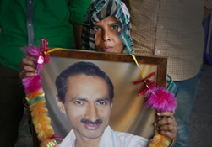

**About:** Faktoo, an anchor for the state owned Doordarshan television station in Srinagar, Kashmir, was assassinated, reportedly by militant separatists, who fired two shots at the journalist with a gun equipped with the silencer. He had received repeated threats from militant separatists because of his work and been kidnapped and detained by a militant group in 1994.

**Murdered on:** 01 Jan 1997

**Attack details:**He was assassinated on January 1 by unidentified gunmen, who used a silencer gun to shoot him.

**Reason to him target:**Faktoo, an anchor for the state owned Doordarshan television station in Srinagar.

**Occupation:**Faktoo had aired pro government news repots that were critical of the separatist movement.

**URL :** <https://cpj.org/data/people/altaf-ahmed-faktoo/>